May 9, 2024

Dear Senator,

On behalf of members of the Canadian agri-food sector, we are writing to express our support for Bill C-280, the Financial Protection for Fresh Fruit and Vegetable Farmers Act. We hope that we can count on your support to move this important piece of legislation forward.

Growing, harvesting, packing and marketing fruits and vegetables comes with many risks. Overhead and capital costs continue to rise, while returns are delayed until payment is collected down the supply chain – usually long after the perishable product has been purchased and consumed.

Ongoing supply chain challenges, a changing climate and inflationary pressures further threaten our food security and the long-term economic viability of the fresh produce sector. Unfortunately, the Bankruptcy and Insolvency Act does not provide workable protection for fresh produce sellers in Canada due to the high perishability of our products and the industry’s longer payment terms.

Last January, Lakeside Produce in Leamington, Ontario, filed for bankruptcy, with creditors owed nearly $188 million. Among those creditors are 17 Canadian produce companies with more than $1.6 million in unsecured claims, and another 45 produce companies across North America owed more than $4.8 million. The significant ripple effects of this one example clearly demonstrate why a financial protection tool is needed to protect our essential sector and food security in Canada.

It is also important to note that the lack of a financial protection mechanism for fresh produce sellers in Canada means that Canadian sellers remain unable to utilize the preferential treatment they previously enjoyed under the United States Perishable Agricultural Commodities Act (PACA). Instead, Canadians selling fresh produce to our biggest trading partner must pay double the bond on the shipment to access the PACA dispute resolution mechanism – a cost that is simply untenable for many Canadian businesses. Having a financial protection tool in place in Canada would also pave the way for the United States Department of Agriculture to restore Canadian produce sellers’ preferential access to the U.S. dispute resolution mechanism for fresh fruit and vegetables and would eliminate the current requirement to post costly double bonds to initiate a complaint.

Bill C-280 would establish a critical financial protection mechanism for fresh produce sellers in Canada to help secure payment in the case of a buyer bankruptcy, in the form of a deemed trust that would operate similarly to the successful PACA model in the U.S. Creating a deemed trust would not impose any additional cost to government, but would help to ensure that fresh produce sellers can continue to support local economies across the country and to provide Canadians with our safe, nutritious fruit and vegetable products.

Businesses selling fresh produce operate in rural, urban and suburban communities, and all communities that rely on fresh produce are left vulnerable to food insecurity if sellers cannot remain financially viable. The enclosed background document provides further information as to how the deemed trust mechanism would work in Canada, and why it is a crucial tool for the Canadian fresh produce supply chain.

Our members across the country are strong supporters of Bill C-280 and strongly urge all Senators to build on the nearly unanimous support received in the House of Commons and to move swiftly to pass this important legislation into law.

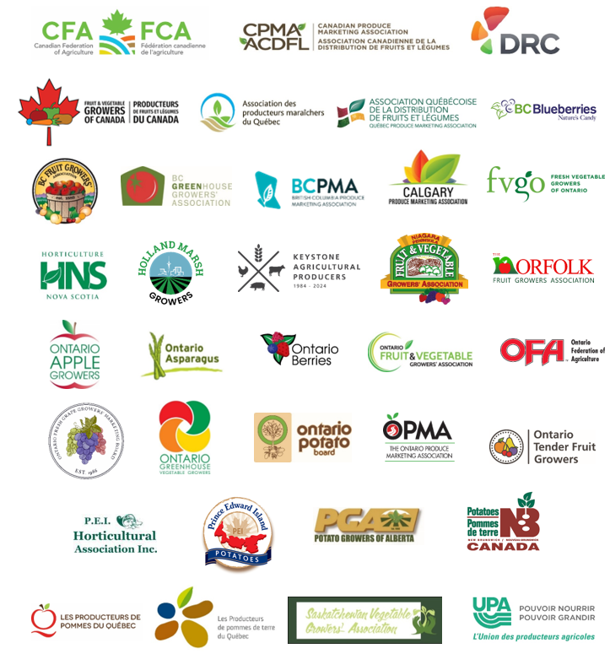
Sincerely,

